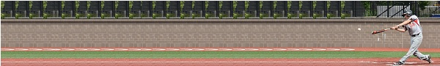
Perfect Practice
A Handbook for Coaches

Ithaca Perfect Practice Handbook
Practice Plans
Player and Parent satisfaction with our league is largely centered around the ability of our volunteer coaches to run effective, well organized teams throughout the season. Our best coaches, are often the ones that are organized and prepare in advance for practices before getting to the field. Organization and preparation demonstrates a commitment to leadership, and our youth will take the lead from a good, organized coach. When practices are scheduled, focus on building fundamentals and have continuous activity, it builds a quality experience all around.
We recognize that as a volunteer coach, pulling a practice together after a day full of business meetings is challenging. This packet was assembled to make practice development easier for coaches of players between the ages of 5 and 12. It has been provided in electronic format (Microsoft Word) to make it easy for coaches to mix and match drills, creating a practice plan that gets all players and coaches involved throughout the practice session.
A typically practice session will be two hours for players in the (9-15 year old), however coaches may need to schedule shorter 1 hour practices depending on the needs of the team. The following would be typical schedules for practices of each length:

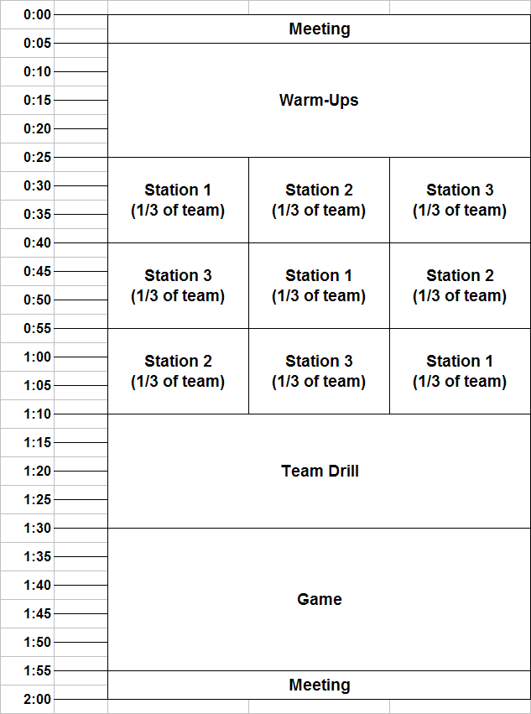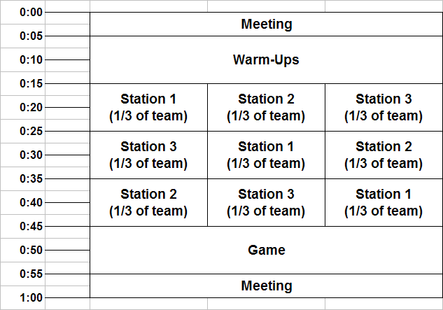
Typical 2 Hour Practice Schedule Typical 1 Hour Practice Schedule

In the following pages, there are details on how to run practice activities (meetings, warmups, station drills, team drills and games) that have been used by many of Clifton Park’s rec and travel team coaches through the years. Refer to the left hand column

and the number graphics ( 5 6
7 8 9 10 11 12 ) indicating ages that might get the most of each drill. The rough duration for each

drill is also provided in the left-most column.

Team Meetings

Duration (Ages) | Drill/Activity | Coaching/Learning Points
5 min  5 6 7 8 9 10 11 12 | Meeting: Start of Practice  - Review the drills to be included in practice and explain the game that will be played at the end of practice (anticipation of the game will help keep them engaged) | As players progress through higher age groups, they will get most of their quality communication from coaches as they kneel in a small circle on the outfield grass. The coaches should all be on a knee in these meetings so they can make sure they have eye contact with every player. Eye contact is a sign of respect and increases the chance that the message is being delivered.
5 min  5 6 7 8 9 10 11 12 | Meeting: End of Practice  - Review the one or two important skills learned at practice  - Give specific examples of new skills that were demonstrated by players during practice  - Compliment players (by name) for showing respect or hustle or effort  - Remind players about next practice or game  - Younger players: (try ending practices with a run around the bases…it makes them smile)  - Pull group together and do a team cheer (hands in the middle) at the end of every practice | Like the meeting at the start of practice, this is a ritual meeting that will continue through every age group. No need to make it drawn out, but the players should get some reinforcement for the time spent together.

Warm Up Routines

(get players ready for athletic activity and generate some team identification)

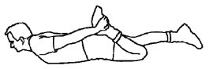
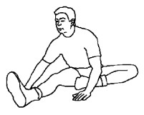
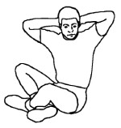
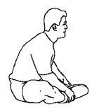
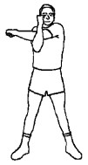
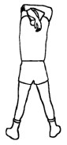
Duration (Ages) | Drill/Activity | Coaching/Learning Points
10 min  9 10 11 12 | Warmup: Sequence  - Jog 2 or 3 times around the inside of the fence. Have the team stay together to reinforce teamwork.  - Bring team together in the outfield and run through a series of stretches.  4  2 3 5 6  1  - Quads (pull ankle up to buttocks, hold for 10 seconds…either lying on stomach or standing)  - Hamstring (sitting, extend one leg, other tucked into inner thigh, bend at hips and reach for toe)  - Spinal twist (sitting, cross leg, twist to that side)  - Groin stretch (sitting, butterfly legs in front, push knees to ground)  - Shoulder stretch (standing, arm to middle of back over head, pull on elbow to stretch)  - Tricep stretch (place hand between shoulder blades, grab elbow with other hand and gently pull, hold for 10 seconds)  - Pair up, do 4 throwing drills  - On knees, forearm with wrist snap, 10x each  - On knees, full windup, 10x each  - Standing throws with quick feet, 10x each  - Long toss, 20x progressively longer  - Wind sprints from foul line to second base…do it together, coach calls out “go”…walk back to line, repeat 4x  - Team meeting to discuss practice plan | Every practice should begin with the same warmup sequence. The older the players, the more important the warmup. At younger ages, the warmup sequence is done to begin a discipline that will be required of the players as they progress. It also gives the team a chance to interact and do an activity together before being broken up into stations.

Duration (Ages) | Drill/Activity | Coaching/Learning Points
5 min  0 11 12 | Warmup: Pickoff Sprints  - Players line up on foul line in outfield  - Coach stands in roughly the same orientation that a pitcher would have to the runners  - Coach mimics pitcher’s motion, stepping on the pitching rubber and getting into a stretch position  - When coach’s foot is on the “rubber”, runners move off of the line as if leading  - Coach either mimics a pickoff move or a delivery to home plate  - Players watch the coach and go back to line if pickoff  - If the coach “delivers” the pitch, runners sprint 70 feet into centerfield (a coach can line up 70 feet from line as a marker for distance to run)  - Players jog back to the foul line and repeat sprints 4x | This is more fun than plain wind sprints and it focuses the team on watching the pitcher when leading off on base. These should be sprints, not jogs, to simulate a stealing situation during a game.
10 min  10 11 12 | Warmup: Playing Catch  - Pair up players with parents  - Line up perpendicular to foul line in the outfield:  - Play catch using a wiffle ball or tennis ball and no glove  - Start about 10 feet apart and back up if the player is catching the ball easily  - Coach can toss underhand or overhand, depending upon the skill of the player | Catching is the hardest skill for a young player to learn. By using a waffle or tennis ball and no glove, you’ll be doing two things: (1) increasing the player’s confidence in their ability so they don’t turn away or close their eyes when a ball approaches, and (2) conditions the player to catch with two hands.  Players should learn to do their throwing warmups in the outfield as they’ll be doing that for as long as they play baseball. Having them throw in parallel prevents injuries.  Have players keep track of number of consecutive catches without dropping the ball.

Duration (Ages) | Drill/Activity | Coaching/Learning Points
10 min  5 6 7 8 9 10 11 12 | Warmup: Base Running  - Line up at home plate  - Each player takes an imaginary swing and runs to first base  - A coach is at first base encouraging the runner to go fast  - Repeat the drill, but start at first base, second base or third base  - End the drill by having the players run out a home run touching all bases | Many older players (9-12 year olds) don’t run hard “through” first base, opting to slow down on the last few steps. The sooner the players learn this simple skill, the less frustrated older age group coaches will be. Also, by having a coach shout encouragement from the coach’s box, the players learn to listen to the base coach – something that will become important in later years. Strangely enough, this drill will help ensure that players run the right way around the diamond during games. The home run is fun for kids of all ages (since that’s what their  baseball heroes do on television) so be sure to end with the home run.

Duration (Ages) | Drill/Activity | Coaching/Learning Points
10 min  10 11 12 | Warmup: Side to Side Drill  - Players pair up. \  - One player (tossing) kneels on ground with 6 balls in front of him.  - Other player stands 8-10 feet away, facing the tosser.  - Kneeling player tosses ball to one side of the fielder then the other. Fielder taps the first 5 balls with his closed glove, diving and catching the 6th – which is thrown farther to the opposite side.  - Tosses should be far enough that the fielder must move his feet one or two steps, but not too far that fielder can’t get to it.  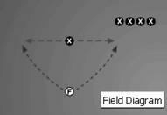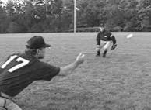 | Great warmup drill. Only do this drill after players have done some warmup as they will work their legs hard and get winded after one cycle. The coach should toss the ball farther to each side for players that are quicker. Stop the drill if the player is standing still and just moving their glove back and forth.  The fun part of this drill is the dive on the last toss. Encourage players to exert themselves trying to make that last catch. Players that do this drill well tend to be the best middle infielders.

Station Drills

(run several stations in parallel, keeping all players busy at the same time)

Duration (Ages) | Drill/Activity | Coaching/Learning Points
5 min  7 8 9 10 11 12 | Station: Fielding Triple Play  - Place 3 balls on the ground, spaced apart by 5 feet  - Have players, one at a time, run up to the first ball, throw it to a coach about 15 feet away…run to the second ball, throw to coach…and run to third ball, throwing to coach  - Coach should be at an angle to the line of balls, on a line towards first base:  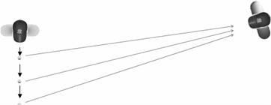  - Repeat the drill until it’s time to rotate stations | This is a very basic drill that every player can do, regardless of skill. It provides the opportunity to teach how to field a ball (alligator hands), set the feet and make a throw to another fielder. Coaches should be teaching proper arm position for the throw.
5 min  7 8 9 10 11 12 | Station: Baserunning on Pop-Ups  - Have players in batting helmets lined up behind 1st base  - One player at a time moves onto the base as baserunner  - Coach plays at deep 2nd base and another coach tosses pop-ups from near home plate  - When ball is in the air, player runs 3 to 5 steps off of first base and watches to see if the ball is caught  - If caught, the player runs back to 1st base  - If not caught, the player runs fast to 2nd base and stops on the base (doesn’t over-run)  - A coach can be in position at 1st and 2nd base to make the play on the runner if they read the situation incorrectly | Younger players don’t always understand when to run and when not to run. This is a drill that reinforces the rules on pop-ups. At this age, do not teach the infield fly rule…just teach going back to the base or running to the next. Make this more fun by having the rest of the team yell “BACK!” if the ball is caught or “GO!” if it is dropped.  The coach at 2nd base should catch some balls and drop others (randomly) to give players a chance to see both situations.

Duration (Ages) | Drill/Activity | Coaching/Learning Points
5 min  7 8 9 10 11 12 | Station: Force Out at 1st Base  - Put players in a line behind 1st base  - Each player, in turn, moves to fielding position off of first base  - Coach plays at 2nd base and coach is at home plate rolling grounders to 2nd  - When grounder is thrown to 2nd base (coach), the fielder moves from fielding position to 1st base to make the force out  - After each turn, switch players at 1st base | This is a basic fielding drill designed to help players understand where they should be playing when fielding the ball and how to move to 1st base, put the correct foot on the base, and make the catch from an infielder. For right handed 1st basemen, the right foot should be on the base when catching a throw. Lefties use the left foot. Teach the player to stand tall at 1st base until the ball is thrown, then to stretch toward the ball. This will make it easier to field bad throws.
5 min  7 8 9 10 11 12 | Station: Force Out at 2nd Base  - Put players in a line in center field  - Each player, in turn, moves to a fielding position at 2nd base (i.e., between 1st and 2nd)  - Coach is playing shortstop and another is rolling grounders to the shortstop position  - When grounder is thrown to shortstop (coach), the fielder moves from fielding position to 2nd base to make the force out  - After each turn, switch players at 2nd base  - Repeat the drill with players at shortstop and coach at 2nd base | This is a basic fielding drill designed to help players understand how to make a force out at 2nd base. At these younger ages, the goal is to ingrain the movement  to the base for a force out and to make the catch. This drill can be augmented with a baserunner coming from 1st base. If so, make sure the runner is wearing a helmet and he starts running only after the coach tosses the grounder.

Duration (Ages) | Drill/Activity | Coaching/Learning Points
10 min  8 9 10 11 12 | Station: Middle Infielder Force Outs  - Split players into two groups with half the group lined up behind 2nd base and half the group behind shortstop  - Coach hits grounders from home plate to either 2nd baseman or shortstop  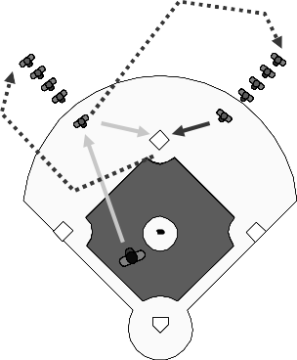  - The player fielding the ground ball must stay in position to read where the grounder is going and the player not fielding the grounder must break to 2nd base to make the force out  - After each play, players switch lines  - Coach hitting grounders should mix up the position getting the grounder to make sure players learn to stay in position to make the play | Covering the base on a force out at 2nd is confusing to younger players. This drill helps condition players to learn the roles of the 2nd baseman and shortstop on the force out play  – staying in position to field the grounder and learning how and when to run to the base to make the catch. Make this a more advanced  play by hitting some balls into the hole between SS and 3rd and between 1st and 2nd.

Duration (Ages) | Drill/Activity | Coaching/Learning Points
10 min  8 9 10 11 12 | Station: Ground Ball Fundamentals  - In infield, pair up three players with three coaches, separated by 12-15 feet  - Players get into a fielding position  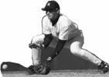  - Coach rolls the ball to the player who fields the ball and tosses it back to the coach, never leaving the fielding position  - Coach quickly rolls the ball back  - Repeat for 6 reps, with 3 sets per player | During this drill, the player needs to stay low to the ground. Emphasize fielding the ball in the center of the body, with glove low to the ground in front of the feet. Throwing hand should be above the glove in an “alligator mouth” position. If the player stays low throughout the drill, their legs should feel the burn. Explain to players that in a real game, they would throw the ball back while standing (i.e., wouldn’t stay low).
10 min  10 11 12 | Station: Fielding Short Field Pop-Ups  - Put a player at 1st base, 2nd base and right field  - Remaining players are in a line by the 1st base dugout (out of the way) with gloves on  - Coach stands at home plate and tosses pop-ups behind 1st base and into short left-center field  - Players run to make the catch | There are several important lessons to be learned in this drill: (1) player roles on short field fly balls,  (2) communication between fielders, and (3) hustle getting to the ball. A surprising number of older players can’t make this play well – including major leaguers. The coach should strive to toss the ball in a location that forces players to run hard and to communicate.
5 min  5 6 7 8 9 10 11 12 | Station: Soccer Ball Hitting Drill  - Place a soccer ball on top of the T (if the T is an open tube place a small bathroom plunger inside the tube)  - The batter hits the ball hard off the Tee.  - If the ball doesn’t explode off the ball then the player isn’t driving through the ball | Every player should be able to hit a soccer ball off the T. And every time they do, they’ll gain more confidence in their hitting.  Coaches should stress all of the same hitting mechanics (e.g., squish the bug, etc.) that apply when hitting a baseball

Duration (Ages) | Drill/Activity | Coaching/Learning Points
5 min  5 6 7 8 9 10 11 12 | Station: Batting Derby  - Set up a T at home plate, but have the batter aligned to an imaginary pitcher at roughly 2nd base (allows other stations to run in left field safely)  - Hit 3 balls off the T into the outfield  - After hitting, have the batter find the ball that went the farthest and stand in that spot in the field  - Have the next player hit 3 balls and stand at the spot of his/her farthest hit…repeat for each player  - The object is to have each player hit the ball farther than his teammates  - Coaches should be in the field to help retrieve balls and find the farthest of each trio of hits | By making the hitting into a contest, players will stay more engaged. At this age, players are naturally competitive and will try harder and listen to instruction better…just to out perform one of their peers. Reinforce good hitting mechanics and take every opportunity to connect good hits with good mechanics.
5 min  6 7 8 9 10 11 12 | Station: Bounce to a Bucket  - Put a large bucket or cooler on a base with the open end on the side, not up.  - Outfielders try and throw the ball into the container.  - Make this drill into a game where players get 10 points for throwing it into the bucket and 5 points for hitting the bucket | Coaches should stress good throwing technique including getting feet set, good arm position before the throw and full follow- through. Teach the players to take their time and make a good throw instead of rushing and making a bad one.

Duration (Ages) | Drill/Activity | Coaching/Learning Points
10 min  9 10 11 12 | Station: Throwing Momentum Drill  - Setup 3 cones approximately 6 feet apart along the basepath between 2nd and 3rd base  - Players should have their gloves on and standing in a line at 3rd base  - A coach has a bucket of balls at mid infield between home plate and 3rd base and another coach stands near 2nd base  - The first player moves to the first cone and gets into a fielding position  - The coach with the bucket rolls a ball to the fielder who fields the ball and shuffles toward the second cone (toward 2nd base) where he makes the throw to the coach at 2nd base  - After making the throw, the fielder continues to move past the third cone then returns to the back of the line | This drill gives each fielder a better understanding of how to create momentum when throwing the ball and following the throw after release. The cones help the fielder to visualize their momentum during the throw. When making throws, the coach should be emphasizing the proper position of the feet and shoulders (pointed toward the target).
10 min  10 11 12 | Station: Catcher Pop-Ups  - Have the catcher suit up in full gear including mask  - Pitcher throws pitches and coach stands behind catcher with a few balls ready to toss in air  - When pitcher throws the ball, coach shouts “up” to indicate if the pitch is fouled up in the air – if so, catcher throws off mask, finds the ball and makes the catch  - If not, catcher returns the ball to the pitcher  - Coach should alternate between pop-ups and not at random intervals to prevent catcher from over anticipating the drill  - Pop-ups should be thrown straight up and to either side of home plate to develop skills in moving to the ball and making the catch | Catching pop-ups behind home plate is one of the most difficult skills to develop in a catcher. This drill helps, but isn’t a replacement for game experience. Emphasize getting the face mask popped off of the catcher’s head to make seeing the ball easier. Also, teach the catcher to turn their back to the field when making the catch.

Duration (Ages) | Drill/Activity | Coaching/Learning Points
15 min  10 11 12 | Station: Catcher Blocking and Throwdown  - Blocking drill, 3 dry blocks each side, 5 blocks each side with equipment:  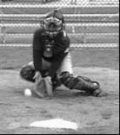  - Step and throw…coach feeds ball, quick jump to align feet, direct throw with good throwing mechanics  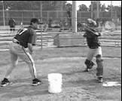 | Coach can start with “dry blocks”, where the coach simulates the toss of a ball into the dirt, to help catchers develop proper mechanics.  Actual blocks should be done with coach tossing ball into dirt on either side.  Step and throw drill should develop a quick orientation of feet and arms, ball out of mitt quickly, direct throw without an extra step.

Duration (Ages) | Drill/Activity | Coaching/Learning Points
15 min  10 11 12 | Station: Batting Practice in Two Cages  - Players awaiting their turn in the cage practice soft toss from the side, then from behind:  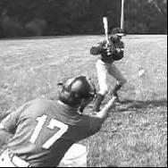  - Inside cage, batting practice off of machine or coach pitch.  - Start with 3 bunts toward third base, 3 bunts toward first  - 10 hits per player – any touch of the ball counted as a hit | Soft toss hitting should focus on quality, not quantity. Players should work on mechanics and a coach should be nearby to provide tips. When hitting soft toss from behind: toss the ball low, starting slow and increasing speed. Player should work on hitting ball in front of plate.  In batting practice, emphasize hitting pitches inside (left “x”), down middle (center “x”), outside (right “x”):  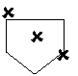
30 min  10 11 12 | Station: Infield – Rapid Fire Grounders  - Split group of players into two groups with half in a line behind shortstop and half at 2nd base  - One coach stands about 20 feet to the left of home plate, another stands 20 feet to the right  - Each coach has 30+ balls at their feet ready to hit  - Coaches hit grounders to the fielders on their side of the infield, one at a time  - As players field the ball, they drop the ball into a bucket sitting on top of second base, then switch lines  - When coaches run out of balls, a player runs in the bucket, dumps half the balls at each coach’s location and the drill repeats | Emphasize good fielding mechanics with legs wide, glove out and down, and throwing hand open above the glove (“alligator  mouth”). After several passes through the line, increase the speed of the grounders. Also, make the drill more advanced by hitting the ball to either side of the fielders.

Duration (Ages) | Drill/Activity | Coaching/Learning Points
10 min  9 10 11 12 | Station: Infield – Four Corners Throwing  - Setup bases at ¾ distance to shorten the throws  - Have a player standing at each base  - Start throwing around the bases clockwise  - After several warmup throws each, coach signals “go” and then counts the number of catches made in 60 seconds  - Repeat the drill throwing the ball counter-clockwise  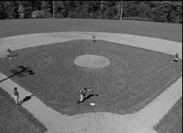 | Emphasize good throws on the runner side of the base, leading the fielder. Have players work on ball transfer between glove and throwing hand and on good throws. Keep several balls handy as there will be throws that get past the fielders.
30 min  7 8 9 10 11 12 | Station: Outfield  - Blind toss  - Younger ages: start with back to coach, toss ball in air, yell “ball”, and have player find and catch  - Older ages: start with back to coach, hit the ball of the bat and have player react to the sound of the hit  - Hit the helmet (place helmet 10’ in front of helmet, toss ball to fielder, throw to hit helmet on a fly):  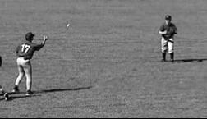 | Each of these drills reinforces important outfielding skills: (1) good first step when chasing down a fly ball, (2) picking up the ball in the air and running to make the catch, (3) making accurate throws on a line to home plate. These drills should be repeated so each player gets 5 to 10 touches on each drill. Also, to make this drill effective, it must be repeated in several practices…not just one.  Coaches should position themselves to make corrections in technique with each player once they’ve rotated to the back of the line.

Duration (Ages) | Drill/Activity | Coaching/Learning Points
10 min  10 11 12 | Station: Rapid Fire Throws – Infield  - Station a player as 1st baseman, in position to make a catch (foot on the base), with an empty bucket on the ground  - Remaining players, with gloves, positioned behind 2nd base in a line  - Coach has bucket of baseballs adjacent to 2nd base on the shortstop side  - Each player at 2nd base straddles the base and takes 8 rapid tosses from coach in succession, transferring the  ball from glove to throwing hand and making a throw to 1st baseman:  - 1st baseman drops ball into the empty bucket on each throw and gets ready for the next throw  - For younger ages, a coach can play 1st base for safety purposes  - After 8 throws, player returns to the end of the line | Run through the line of players no more than twice to ensure arms don’t get hurt. Emphasize good position of both hands in front of the chest when making the catch at  2nd base. Demonstrate the proper position of the shoulders (lined up with the 1st baseman) prior to each throw. And work on a fast transfer  of the ball from glove to throwing hand. To add some excitement for the 1st baseman, have the last throw from each player be in the dirt – and work with 1st baseman on proper fielding mechanics when scooping bad throws.
10 min  10 11 12 | Station: Pitcher Covering First Base  - Station a player at pitcher, 1st base, and shortstop  - Coach is at home plate  - Pitcher to coach at home who tosses a grounder to either shortstop or 1st base  - When grounder is to 1st base, the pitcher moves to cover the base  - The 1st baseman should toss the ball to the pitcher while they’re on the run  - Coach mixes up with grounders to short so the pitcher doesn’t over-anticipate  - Repeat drill with a runner from home plate  - The first baseman can decide whether to make the putout by themselves or toss it to the pitcher. | The purpose of this drill is to teach pitchers to cover first base on grounders hit to the right side of the infield (toward 1st or 2nd base). It also teaches the first baseman when to toss it to the pitcher or to tag the base himself. Teach the first baseman to wave the pitcher off if he takes it himself. Teach the  pitcher to approach 1st base at a 45 degree angle. If necessary, setup cones to guide the pitcher’s run to the base.

Duration (Ages) | Drill/Activity | Coaching/Learning Points
10 min  10 11 12 | Station: Pitching – Hitting Spots  - Pair up a pitcher with a catcher in the bullpen (setup two pitchers/catchers if there is space)  - Have each pitcher throw 12 pitches with catcher setup down the middle…first 6 pitches are fastballs down the middle, next 3 pitches are changeups, final 3 pitches are fastballs increasing in speed progressively  - Pitcher throws 12 more pitches, with 4 thrown inside, 4 down the middle, and 4 outside (catcher sets up in each position before the throw)  - Pitcher keeps track of number of pitches that hit the glove in the proper position | Pitchers at the age of 10 and above should be working towards better control of their fastball, hitting spots inside and outside on batters. This drill involves enough throws that it allows good initial control (down the middle) followed by practice hitting spots.
10 min  10 11 12 | Station: Infield Grounders  - Station players at each infield position, including catcher (no gear)  - Coach hits grounders:  - to 3rd base, throw to 1st, then to catcher, back to 3rd for a tag on the base, then back to catcher  - to shortstop, throw to 1st, then to catcher, back to shortstop (tag on 2nd base), then back to catcher  - to 2nd base, throw to 1st , then to catcher, back to 2nd (tag on 2nd base), then back to catcher  - to 1st, make the tag 1st base, throw to catcher, back to 1st (for a repeat tag), then back to catcher  - bunt to catcher, throw to 1st, then back to catcher (tag at home plate)  - Repeat sequence doing double plays from 3rd to 1st to catcher and the same from 2nd to 1st to catcher | This is a drill that seeks to put basic infielding skills to the test, but also do it at “game speed”. By having throws go rapidly from fielder to 1st to catcher then back to the base, all  players must remain engaged in the play. Encourage the throws and tags to be done rapidly, simulating a fast-paced game.
10 min  5 6 7 8 9 10 11 12 | Station: “Hot Potato”  - 4-6 players get into in circle and in position to field a ground ball (no gloves)  - Player/coach rolls the ball to wherever they wish  - Any player letting ball past them is out  - Last player standing wins, using deception adds fun, using two balls adds more fun. | This is instructional, a little competitive and fun for the team. The coach should be helping players focus and giving pointers on fielding position.

Duration (Ages) | Drill/Activity | Coaching/Learning Points
15 min  0 11 12 | Station: Hitting Inside, Middle, Outside  - Using cones behind 2nd base and shortstop positions, divide the field into thirds  - Setup L-screen 35 feet from home plate for batting practice  - Position a player in left, center and right field  - Remaining players wearing helmets and wait in dugout to bat  - Coach pitches ball at ¾ speed  - Batter works to recognize whether pitch is inside, down the middle or outside  - Inside pitches should be pulled; down the middle should be hit up the middle and outside pitches should be hit to opposite field  - Coach should vary pitch location to work on all three zones  - After 3 hits to each zone, batters rotate | Batters become more effective when they learn to recognize the pitch they are hitting, and adjust their hitting accordingly. For a right handed batter, the location where the bat should make contact with the ball is indicated by x’s:  This drill works well in conjunction with separate hitting stations for soft toss and batting cage hitting.
10 min  5 6 7 8 9 10 11 12 | Station: ESPN Pop-ups  - Use a tennis or wiffle ball  - Coach tosses a pop-up, making the player run for the ball  - Players attempt ESPN “highlight” plays by running and diving or sliding to make the catch  - Don’t hit or throw the ball too high; arc the ball as a 6 or 7 year old would hit it | At younger ages, players don’t always realize that they should run for pop-ups, thinking that another player will make the catch. This game reinforces the importance of going after the ball – and the ESPN angle makes it a blast.

Team
Play

(teach players how to interact with others on the field)

Duration (Ages) | Drill/Activity | Coaching/Learning Points
15 min  0 11 12 | Team Play: Situation Drills – Infield  - Players in position at 1st, 2nd, 3rd and shortstop  - Coach is at home plate hitting grounders  - Remaining players are in a line in centerfield wearing helmets, ready to be baserunners  - Baserunner starts at 2nd base  - Grounder is hit to any one of the infielders  - Runner attempts to advance from 2nd to 3rd base on the throw to first base  - First baseman makes the catch at first and runs the ball into the infield  - If the runner breaks for 3rd base, the 1st baseman throws the ball to 3rd where the 3rd baseman attempts to make the tag out  - Baserunners should slide into 3rd base on this drill  - If the infield is too hard, move the drill to the outfield and setup bases to make the slide safer into 3rd base  - Rotate new players into positions after several rounds through the infield with grounders | The coach should work with baserunners on judging whether to break for 3rd base or not. The infielders should be communicating with each other to alert the 1st baseman whether or not the runner is attempting to advance. Ensure that the 3rd baseman is in the proper position to make the tag.
15 min  0 11 12 | Team Play: Throwing Star  - Setup a player at 1st base, 2nd base, shortstop, 3rd base and catcher (no gear)  - Remaining players are behind home plate with helmets  - Drill starts with a baserunner starting from home plate running to 1st base  - When runner gets ½ way to 1st base, the coach throws a ground ball to the 2nd baseman who fields the ball and throws to the 3rd baseman, who throws the ball to the 1st baseman, who throws it to shortstop, who throws it home  - Baserunner keeps running around the bases and tries to beat the throw to home  - Rotate players into positions every few runners | The coaches should make sure that players stay in position and don’t cheat into infield. Emphasize good throws and rapid transfer of ball from glove to throwing hand. If fielders make good catches and throws, they should beat the runner every time.

Duration (Ages) | Drill/Activity | Coaching/Learning Points
15 min  10 11 12 | Team Play: Bunting  - Infield and catcher take positions in the field  - Remaining players put on helmets and make a line by the 3rd base dugout  - The coach sets up two orange cones, separating the bunting zones into three sections: right side, middle, and left side  - The coach has a bucket of balls about 40 ft. from the plate for pitching to player that is bunting  - An empty bucket is placed at all three bases where infielders deposit fielded balls  - When the coach pitches, the bunter at the plate pushes the ball toward either line.  - The 1st and 3rd basemen charge the bunt and throw it to the 2nd baseman covering the bag at 1st. The fielders must play the ball out, even if it is not fielded cleanly.  - After bunting, the batter goes to the end of the line  - Rotate players in the field after ~10 bunt plays | This is a good drill for practicing bunting (hitters) and proper infield rotations during the bunt.  Emphasis should be placed on communication between 1st and 2nd basemen. Make sure all the infielders get back to normal depth before the next pitch is delivered. This drill can be repeated with force plays at 2nd and 3rd base.  Prior to running a specific situation, the coach should walk the infield through their proper motions after the bunt.

Duration (Ages) | Drill/Activity | Coaching/Learning Points
15 min  6 7 8 9 10 11 12 | Team Play: Throwing Ball to Infield (Young Players)  - Split team into two groups, with one group lined up in center field and the other lined up at second base  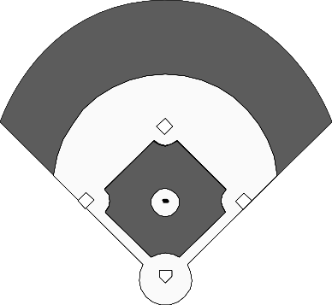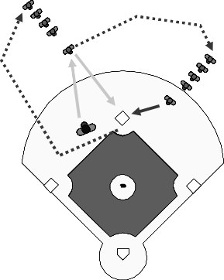  - Coach throws grounder or popup to center fielder  - Second baseman runs to cover second base  - Outfielder chases down the ball and throws to second baseman  - Outfielder goes to the back of the infielder line  - Infielder goes to the back of the outfielder line | Young players don’t always know what to do when playing the outfield. This is a simple, but effective, drill that teaches the outfielder to make a play on the ball  and teaches the 2nd baseman to cover the base.

Duration (Ages) | Drill/Activity | Coaching/Learning Points
20 min  9 10 11 12 | Team Play: Situation Drills – Outfield  - Players are positioned in left, center and right field  - Catcher should be in pads at home plate  - 1st baseman is mid-infield as the cutoff man  - Remaining players have helmets on and are in a line near bases involved in the drill  - Coach sets the drill as one of the following:  - Hit and run, with runner at second and attempted throw out at home  - Shallow outfield popup with tag at 3rd, throw to home  - Runners leading off of 1st and 3rd…catcher attempts pickoff at 1st or 3rd with outfield backups (coach pitches and coaches at bases)  - Overthrow of base on a force-out with outfield backup and throws ahead of the runner (coaches at bases)  - Rotate outfielders and runners after 10 plays | These drills are focused on getting the outfield to understand its role during different situations. The coach should use each success and failure as an opportunity to teach the right thinking and skill. This is also a good opportunity for runners to make good decisions – whether to run home or not or whether or not to take an extra base.
15 min  10 11 12 | Team Play: Situation Drills – Infield/Outfield  - Players in positions – remainder of players wear helmets and are baserunners  - Coach is at home plate hitting ball to different positions  - No outs, runner at first base, coach at third, hit to players in outfield…throw in front of runner  - No outs, runner at 2nd base, grounder to infield…check runner and throw to first base (repeat for runner at 3rd base)  - No outs, runner at 2nd base, fly ball to outfield…hold runner at second  - One out, runner at 1st base, grounder to infield…get the sure out  - One out, runner at 1st and 3rd base, fly ball to outfield…make throw to home OR hold runner at 1st, depending upon depth of hit  - Rotate runners and fielders every few plays | In this drill, everyone should be moving on every play. With runners in position and hits to the outfield, there are lots of possibilities. Before each play, coach calls out the situation. After each play, coach comments on what was done correctly and what should be improved. If done wrong, repeat the situation with the same players to reinforce the learning.

Duration (Ages) | Drill/Activity | Coaching/Learning Points
15 min  0 11 12 | Team Play: Ball in the Dirt  - Put players in all infield positions, including catcher (with full gear)  - Remaining players put on helmets and wait in line at the 1st base dugout  - Drill can be run with coach or player as the pitcher  - Start with runner at 1st base  - Pitcher throws from a stretch position and 1st baseman holds runner on base  - Pitcher throws pitch to catcher and baserunner reads whether the ball is in the dirt or not…pitcher should vary pitches randomly, throwing roughly 1/3 of the pitches in the dirt  - If in the dirt, the catcher works to block the pitch from getting past and the baserunner extends their lead – stealing 2nd base, if possible  - After each ball thrown in the dirt, rotate runners | A coach should be positioned at 1st base and one should be near the catcher. The 1st base coach should be talking to the baserunner as if in a game situation – telling them how much to lead and whether to go on a passed ball or to come back (good practice for the 1st base coach).  Provide instruction on primary and secondary lead. Coach near catcher should be watching for blocking technique and providing catcher with critique. Drill can include a throwdown to the base by the  catcher. It can also be run with baserunners at 2nd or 3rd base.

Duration (Ages) | Drill/Activity | Coaching/Learning Points
15 min  0 11 12 | Team Play: Pick-off, Steal, and Catcher Throwdown  - Have players man positions at pitcher, catcher (in gear, including mask), 1st base and shortstop  - One runner with helmet at 1st base  - Remainder of players have helmets on and wait in foul territory near the 1st base dugout  - First base coach in coach’s box  - Runner leads off from 1st base  - Pitcher throws from stretch position while 1st baseman holds on the runner  - Pitcher either delivers to the plate or executes pickoff move to 1st base  - If pitcher delivers, runner steals 2nd base  - Shortstop breaks to 2nd base on the pitch to take the throwdown from catcher  - Runner rotates to end of runner’s line  - Change catchers and pitchers after each full rotation of runners (to preserve arms) | This is a fun drill for the team, but it also teach many skills associated with stealing. The 1st baseman practices giving the pitcher a target and making a good tag on a pickoff.  The pitcher practices their pickoff move and their delivery from a stretch. The catcher gets to practice their throwdown, including footwork. The shortstop can practice proper positioning for the tag at second and the timing of the break for the base. And the  baserunner learns how to take a lead, the proper distance from 1st base, the dive back into 1st on a pickoff, reading the pitcher and sliding into 2nd base.  If catchers and pitchers complain of arm pain, the drill can be simplified with coaches doing throws, with players on 1st, 2nd and as runners.

Games

(fun competition that reinforces basic skill development)

Duration (Ages) | Drill/Activity | Coaching/Learning Points
5 min  5 6 7 8 9 10 11 12 | Game: Tag  - Have all players wear their baseball gloves and stand in the infield  - Have players guess a number from 1 to 12 (or whatever number of players are present)…the person who guesses is “it”  - The person that’s “it” chases others around the infield and only tags them if he/she uses the glove with the ball in it | This is more fun than instructional. Even so, having the players run around with their gloves increases their comfort with the glove. By teaching them to tag with the ball in the glove, they’ll be learning a skill that will become more important at 8 years old and above. If the ball doesn’t stay in a player’s glove, have them tag with two hands.
20 min  7 8 9 10 11 12 | Game: Nickels  - Make up 2 teams of 6 players  - In this game, there is no baserunning  - Each player gets an at-bat  - Outs are any ground ball fielded cleanly by infielder, any ball in the air that is caught, or 3 strikes  - A single is any hit where there is an error in the infield or a ground ball gets through the infield  - A double is any base hit that gets by the outfielders  - A triple is any ball hits the fence (or put another marker up in the field)  - A HR is a ball that makes it past a pre-set marker or clears the fence  - Have players in different positions every inning  - Once a team is ready to hit the coach pitches…if defensive players are not ready, too bad – this encourages having gloves ready and running on and off the field | This game is good practice for offense and defense. Players hit the ball so it can’t be fielded. The coach can reinforce hitting mechanics that are obviously wrong (it’s hard to do too much mechanics work during a game like this).  Defense must be ready to make the play and must use the skills they’ve been practicing in drills.

Duration (Ages) | Drill/Activity | Coaching/Learning Points
5-10 min  7 8 9 10 11 12 | Game: Crosswise Throwing Relay  - Line up players in two lines as shown without gloves:  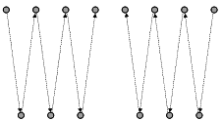  - Start with a tennis ball on one end of each group  - Players throw back and forth to the next person in line (crosswise) until the ball gets to the last person  - Run this as a relay race with two teams or have all players on one team and compete against time | Running this drill with a tennis ball and no gloves concentrates players on catching with two hands and making accurate throws.
15-30 min  7 8 9 10 11 12 | Game: Wiffle Home Run Derby  - Setup a base within 30 feet of the outfield fence  - Split group into two teams  - One team is in the field, guarding the fence  - Other team is at-bat  - Use small waffle balls (practice golf balls)  - Each player on the batting team gets an at bat  - Count balls hit over the fence – balls intercepted by the fielding team (whether or not caught) that don’t clear the fence do not count as a home run  - Keep score (number of home runs total by each team) | This is a great game because it is fun and it forces players to have good hitting mechanics. The ball won’t clear the fence unless there is good bat speed and good contact.  This game can be played even when it is drizzling or raining – in fact, it’s probably more fun in the rain (for the players). Move the base farther from the fence if too many home runs are being hit.

Duration (Ages) | Drill/Activity | Coaching/Learning Points
5 min  6 7 8 9 10 11 12 | Game: Grounder Relay  - Split team into two relay teams  - Line up both teams perpendicular to the foul line in the outfield (Figure 1)  - Players wear their fielding gloves  - Two coaches stand in center field and create a finish line for runners  - Each coach has a soft (t-ball) baseball and rolls a grounder to the first runner  - First runner fields the ball with their glove and runs to the coach in center field  - When runner reaches coach, he/she throws a grounder to the next player in line who fields and runs to center field (repeat until all players have made it to center field)  - If there is an odd number of players, a coach or brother/sister can fill in the last spot  - Repeat the relay two or three times, mixing up teams if they are very unbalanced | While a simple race, this activity provides the opportunity to teach a few simple, but important, skills:  - Proper fielding position on grounders  - Running with the glove tucked into the chest  - Being ready to make a play when its your turn (baseball is a game of waiting, interrupted by action…like this race)
10 min  7 8 9 10 11 12 | Game: Baserunning Relay Race  - Split the team into 2 groups with half of the group lined up behind home plate and half of the group behind 2nd base  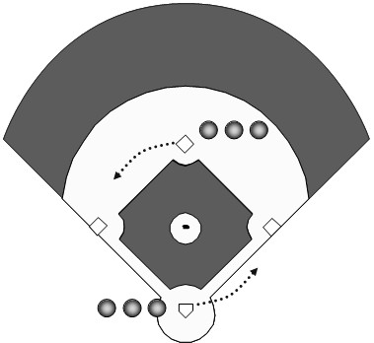  - First runner in each line starts with a ball in hand and, on the coach’s signal, runs around the bases until returning to their starting base…where the ball is handed to the next runner  - Continue through the group until each player has run once | Before starting this race, show runners how to “round” each base and how the foot should touch the base on the inside corner. For safety, have a coach managing each line to be sure the line of runners stays out of the way of the runner with the ball.

Duration (Ages) | Drill/Activity | Coaching/Learning Points
20 min  8 9 10 11 12 | Game: Cut-Throat Scrimmage  - Divide team into three groups of 4  - Two teams are on defense, one is at bat  - Each time a team comes to bat, put a runner onto 1st base  - 4 runs or 3 outs ends each team’s at bat  - Coach pitches and players make plays like a real game | While a fun game, cut-throat provides the opportunity to make force-outs, for good baserunning, and is a way to give players many swings of the bat without running a boring batting practice.
15 min  5 6 7 8 9 10 11 12 | Game: Wiffle Ball Game  - Use a large wiffle ball and an oversized plastic bat  - Split into two teams, have parents fill in positions on field  - If a ball is hit to a parent, the ball should be handed to the next closest player with instructions on where to throw the ball (be sure the player receiving the ball is looking)  - Team at bat stays in dugout or where dugout would normally be located  - Coach does soft toss to batter from 8 feet away in foul territory (i.e., not from direction of pitchers mound but from the side)  - Run out all hits; if a force-out is made, then have player return to the bench  - Every player bats, then switch teams at bat  - Three innings is the longest this game should last | The most important part of this is that it’s a game. Kids like games more than drills, so every practice should end with some kind of game. By using a wiffle ball and bat, the stress of getting hurt or of not getting a hit is eliminated. Kids can just play and enjoy the game.  There are a few technical points that can be reinforced during the game:  - Running through first base  - Running fast between bases and stopping on 2nd and 3rd  - Batter should watch the ball until it hits the bat  - “Squish the bug” (during the swing) with the foot farthest from the pitcher’s mound  - Players in the field can shout “1 – 2 – 3, hit the ball to ME!” to keep them focused on the batter  - Explain force-out if it happens  - Have players race in and out of dugout to reinforce hustle on the field

Duration (Ages) | Drill/Activity | Coaching/Learning Points
15 min  5 6 7 8 9 10 11 12 | Game: Throwing Baseball Game  - Split into two teams, have parents fill in positions on field  - Use a soft (t-ball) baseball  - Team at bat stays in dugout or where dugout would normally be located  - Coach whispers to each batter which position to throw the ball to (i.e., their “hit”)  - Run out all “hits”; if a force-out is made, then have player return to the bench  - If a ball is “hit” to a parent, the ball should be handed to the next closest player with instructions on where to throw the ball (be sure the player receiving the ball is looking)  - Every player “hits”, then switch teams at bat  - Three innings is the longest this game should last | The fun part of this game is that it looks like baseball, with fielding and running – but without the complication of hitting. By whispering the position to which a “hit” should be directed, the coach can teach the positions on the field. Those players that can throw the ball hard enough to reach the outfield will feel a real sense of accomplishment doing that (and it might give them a chance to stretch their “hit” into a double).  Reinforce the following during the game:  - Running through first base  - Running fast between bases and stopping on 2nd and 3rd  - Players in the field can shout “1 – 2 – 3, hit the ball to ME!” to keep them focused on the batter  - Explain force-out if it happens  - Have players race in and out of dugout to reinforce hustle on the field

